**Accounts and Financial Reporting pending requirements**;

1. **Customer Master**: -
2. Customer Rebate and respective provisions in Chart Of Accounts: - A provision entry needs to be passed in background (GL is created in COA) whenever a sales invoice is posted to a customer ledger who is having rebate agreements (Fixed % on sales) with company.
3. **Fixed Asset Master**: -
4. Fixed Asset Masters and related set-up should be available in production environment as per Fixed Asset grouping in COA.

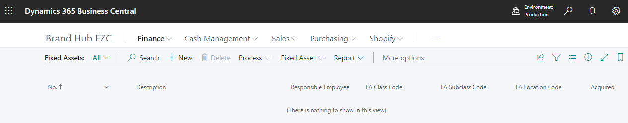

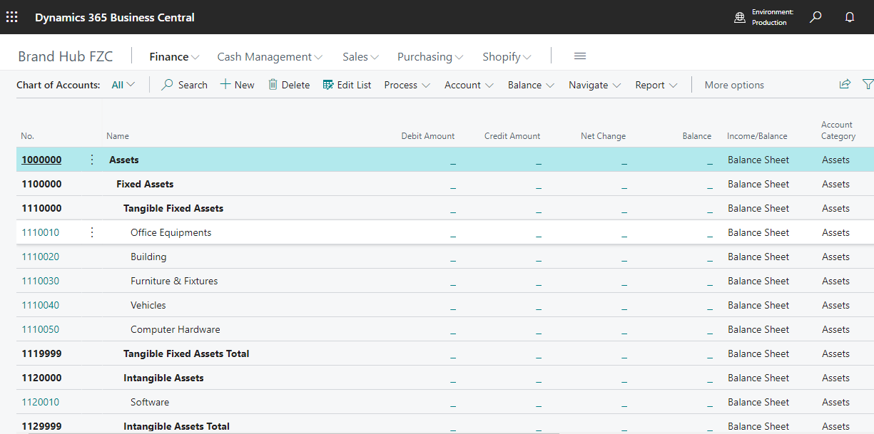

1. **Employee Master**: -
2. Changes in Employee Master as per enclosed file and setting up employee dimension to account employee claims and related expenses.



1. **Banking, Payments & Collection**: -
2. PDC Module for PDC Receipt and PDC Payments: - If Module is not available, system should facilitate auto conversion of PDC entries to bank ledger on PDC Maturity Date.

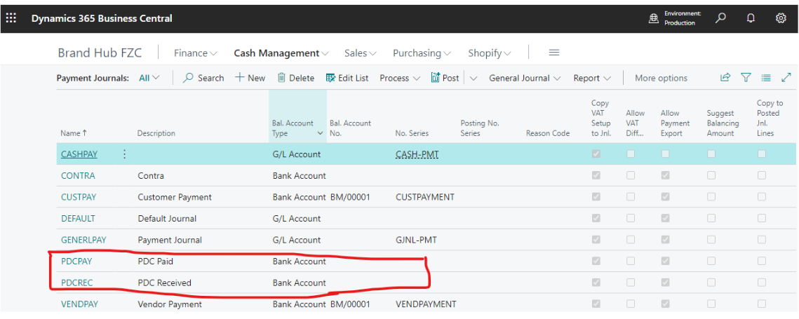

1. Bank Reconciliation: - System to facilitate Manual Bank reconciliation (At present, bank reconciliation can’t be performed manually due to lack of check number in bank ledgers and reconciliation template).
2. **Chart Of Account**: -
3. Account subcategory: - Needs to create account subcategory in COA to map Trading Income and Trading Expenses to calculate Gross Profit and Operating Income and Operating Expenses to calculate Net Profit.

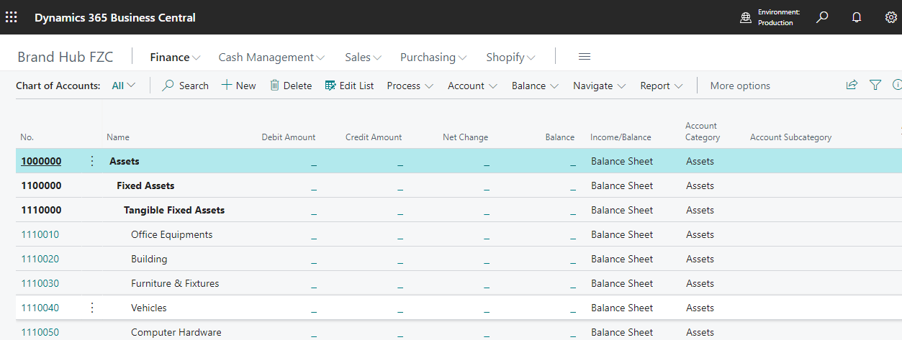

1. **Financial Reporting**: -
2. Balance Sheet: - No balance sheet entries are reflected.

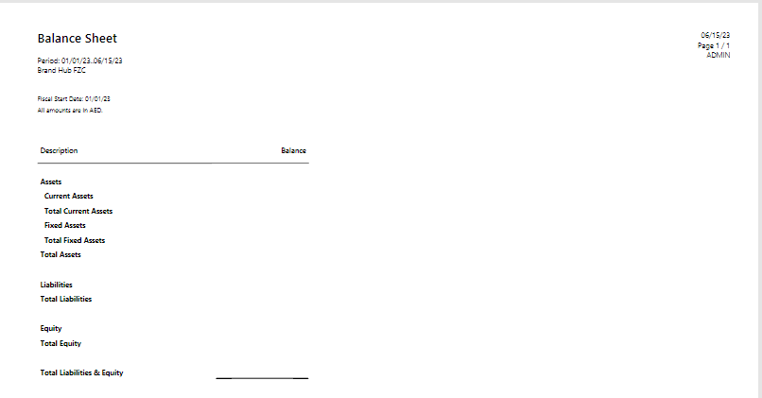

1. Income Statement: - No Income Statement entries are reflected.

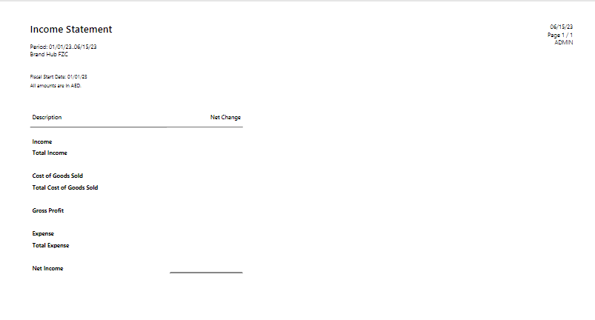

1. Statement of Cash Flows: - How to change GL Account categories as per GL in Chart of Accounts. How to Map the same as per COA to reflect in Cash flow Statements.

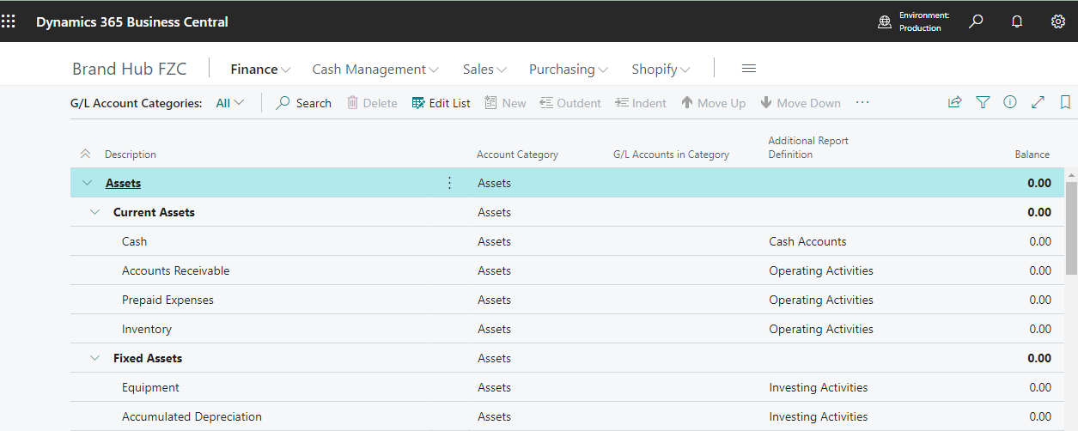

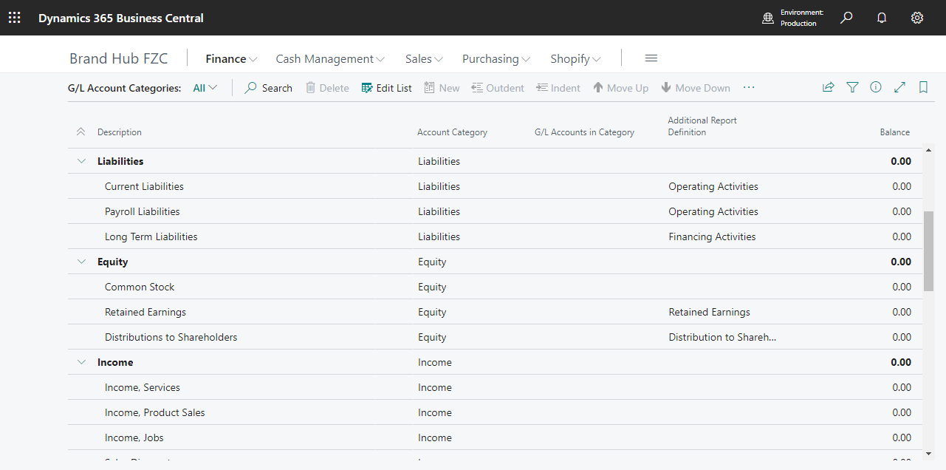

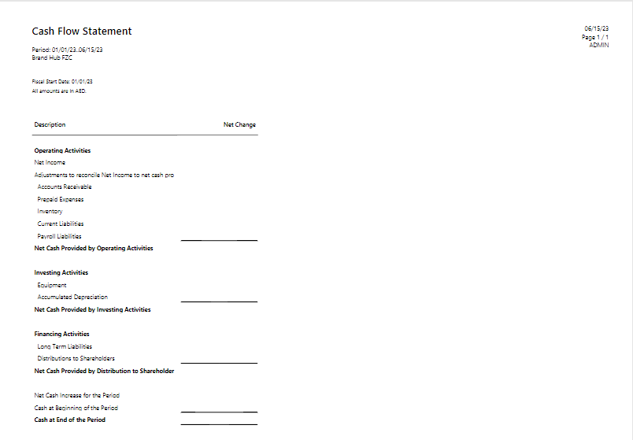

1. Statement of Retained Earnings

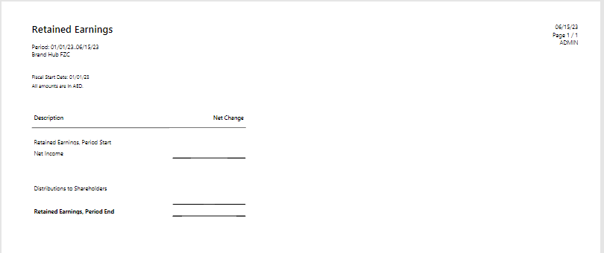

1. **VAT Reports**: -
2. VAT Entries: - For Entry No:1 (purchase invoice entry), even though VAT Business Posting Group is “VAT EXP” system is posting with VAT Product Posting Group “VAT 5” which is incorrect and needs a permanent solution to change VAT Product Posting Group “No VAT”.

Also, For Entry no’s 31,32,33,34,39,42,43 and 44 (customer prepayment entries) and Entry no’s 36,38,41,46 and 48 (sales invoice entries) system are posting with VAT Product Posting Group “VAT 5” which is incorrect and needs a permanent solution to change VAT Product Posting Group “No VAT”.

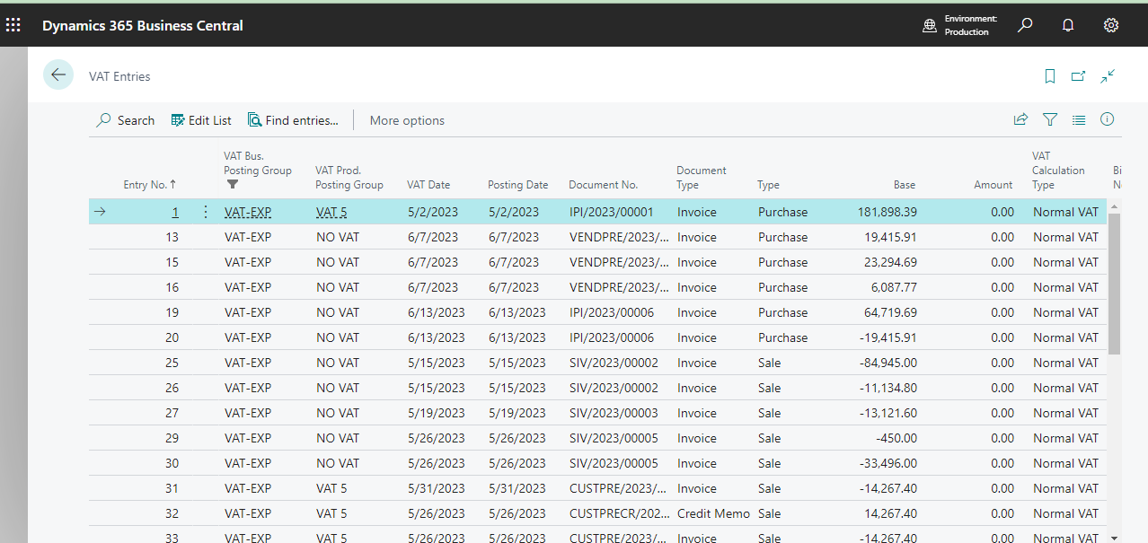

1. VAT Statements: -How to do the set up?

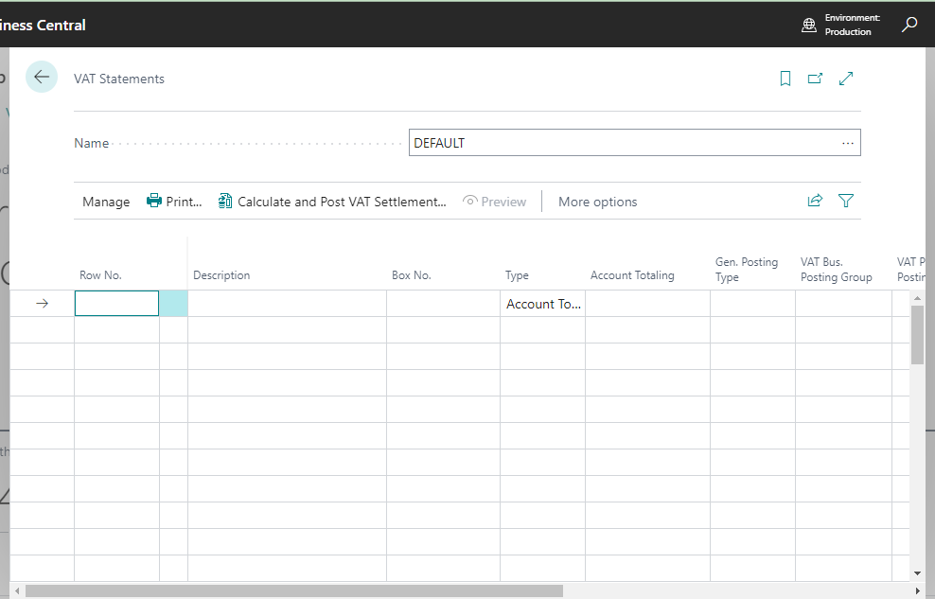

1. VAT Register:- Document numbers are not displaying in full as per number series defined.

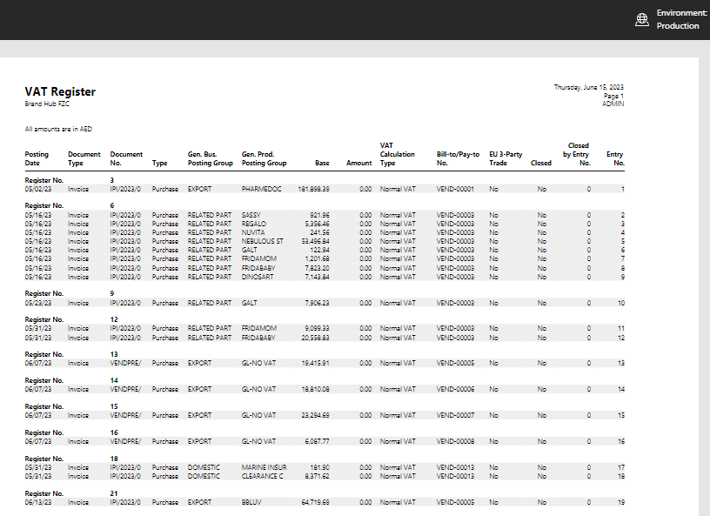

1. VAT Returns: -How to do the set up?

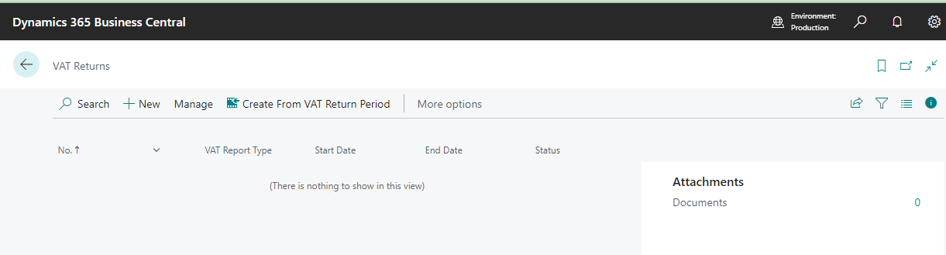

1. **Prepayments**: -
2. For Export customer, prepayment entries are posted to GL code 2200030 (Prepayment-Debtors (Domestic)) instead of GL code 2200040 (Prepayment-Debtors (Export)).

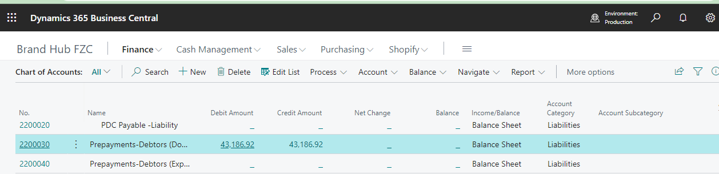

1. **General Ledger Setup**: - Please remove highlighted Item Charges mapping in production environment;

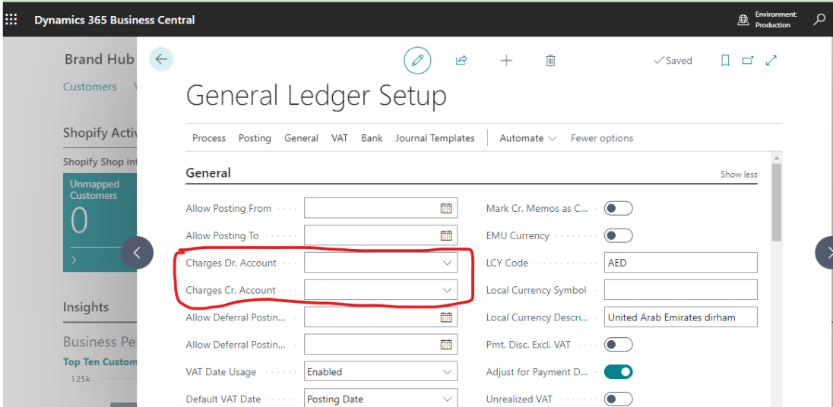

1. **Royalty Master: -** System is calculating Royalty based on the supplier currency and not converting to AED**.**
2. **MIS Reports**: - To be discussed.